1. List out all documents present in books collection

🡺 Select * from c

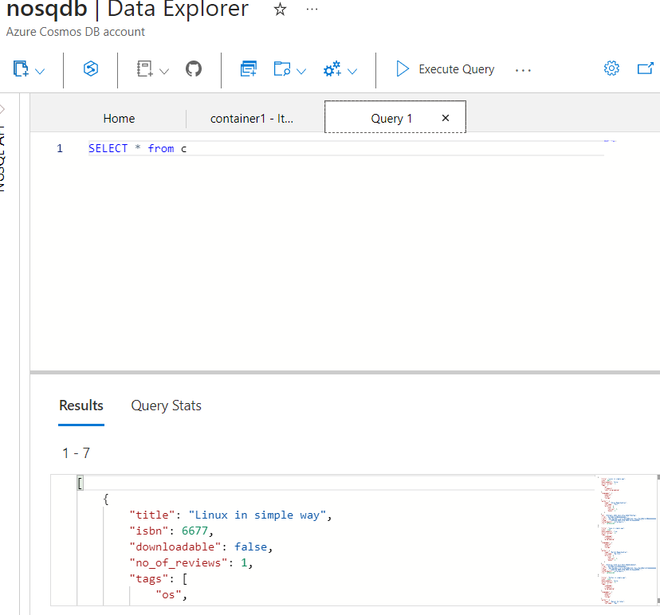

1. Read all documents from the books collection where tags array contains ‘database’ element

🡺 select * from c where array_contains(c.tags, “database”)

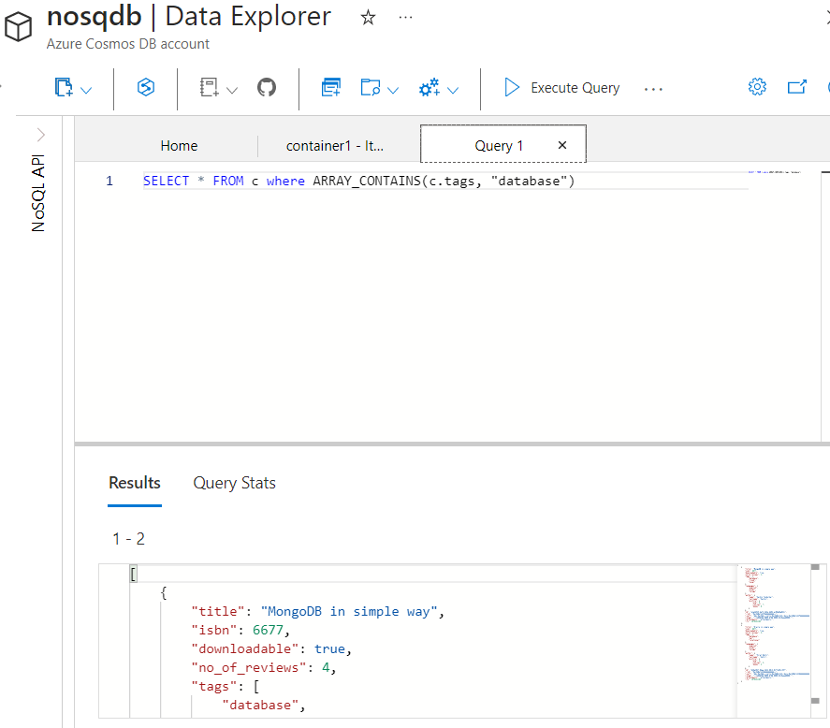

1. List out all documents from books collection where author’s profile contains exactly 2 courses

🡺 select * from c where c.author.profile.courses = 2

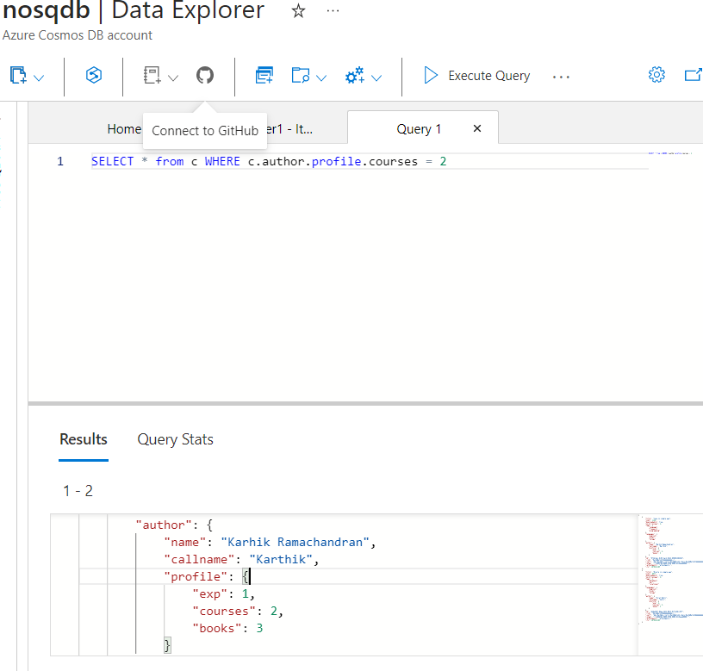

1. Select all documents from books collection where tags array is exactly equal to [“language”, “freeware”, “programming”]

🡺 select * from c where c.tags = [“language”, “freeware”, “programming”]

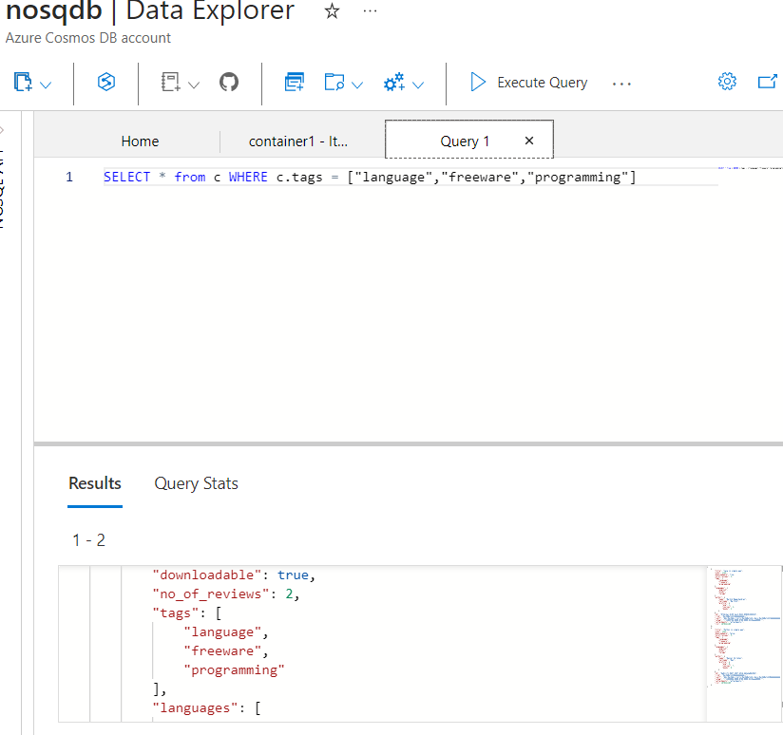

1. List out all documents where tags array contains ‘Programming’ element

🡺 select * from c where c.tags = “programming”

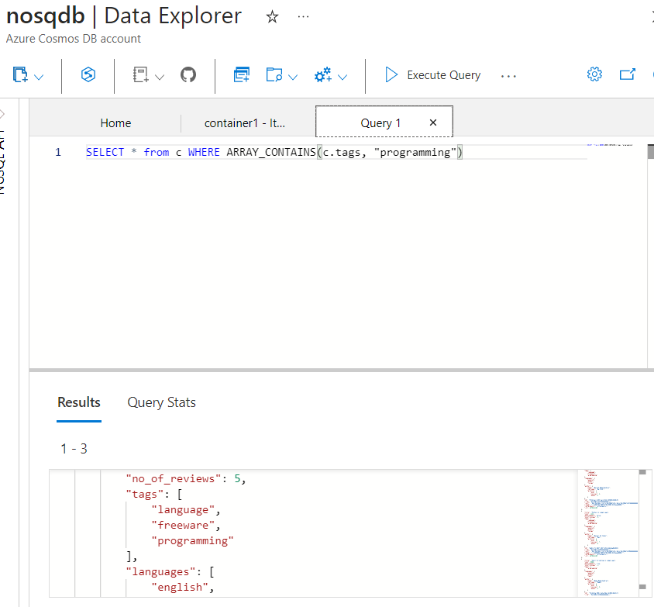

1. List out all documents where languages array contains ‘telugu’ element

🡺 select * from c where array_contains(c.languages, “telugu”)

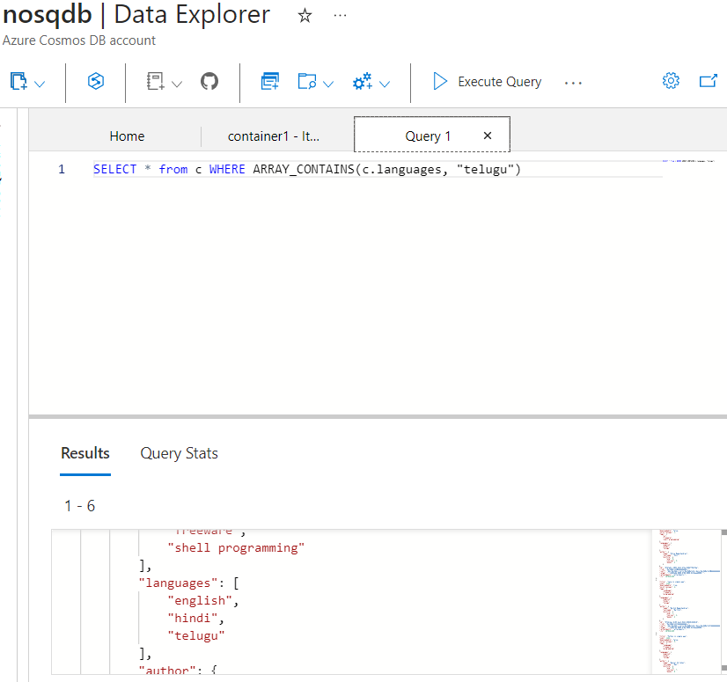

1. Find total number of documents present in book collection

🡺 select value count(1) from c

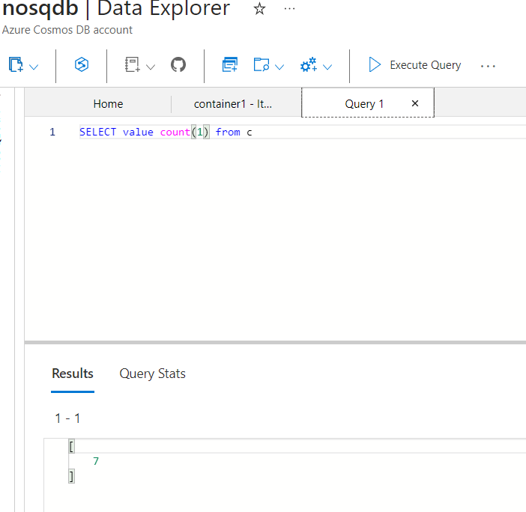

1. List out first document present in book collection

🡺 Select top 1 * from c

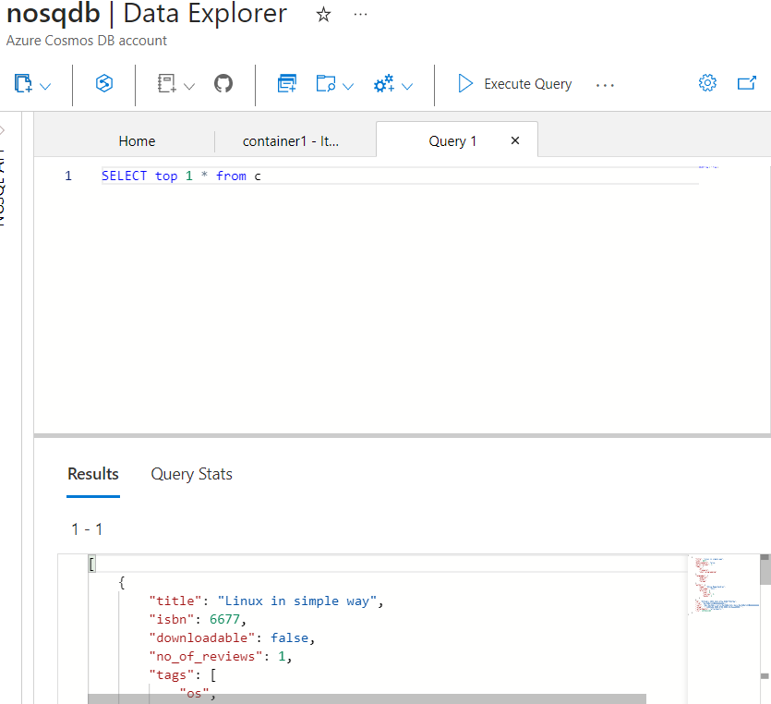

1. Select all documents where either no_of_reviews > 3 or tags array contains programming element

🡺 select * from c where c.no_of_reviews > 3 or array_contains(c.tags, “programming")

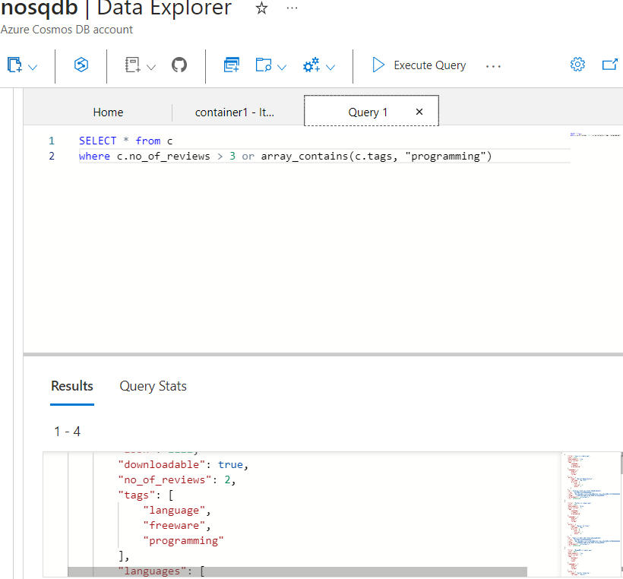

10) Select all documents where either no_of_reviews is less than 3 or downloadable is true or author profile contains atleast 2 books

🡺 select * from c where c.no_of_reviews < 3 or c.downloadable = true or c.author.profile.books >= 2

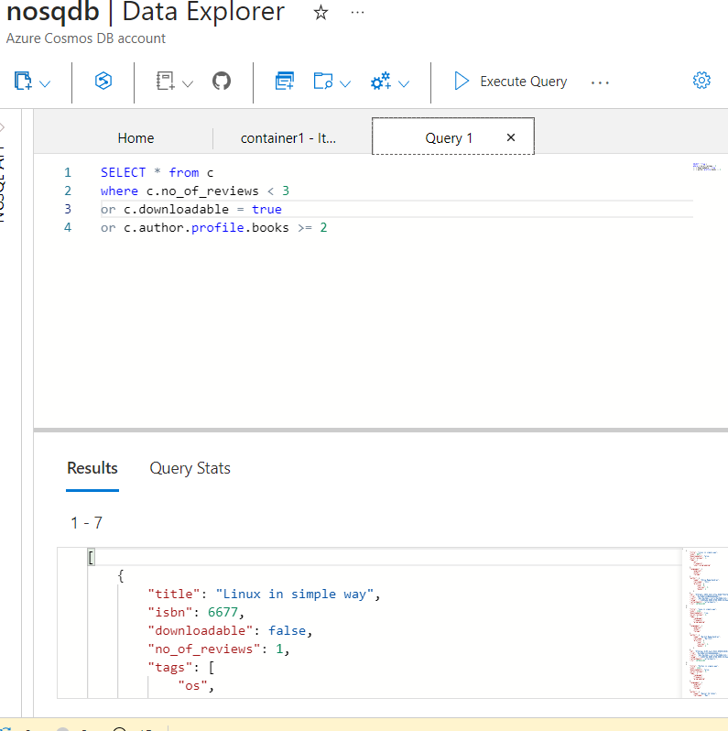

11) Select all documents from books collection where no_of_reviews is not equal to 3

🡺 select * from c where c.no_of_reviews != 3

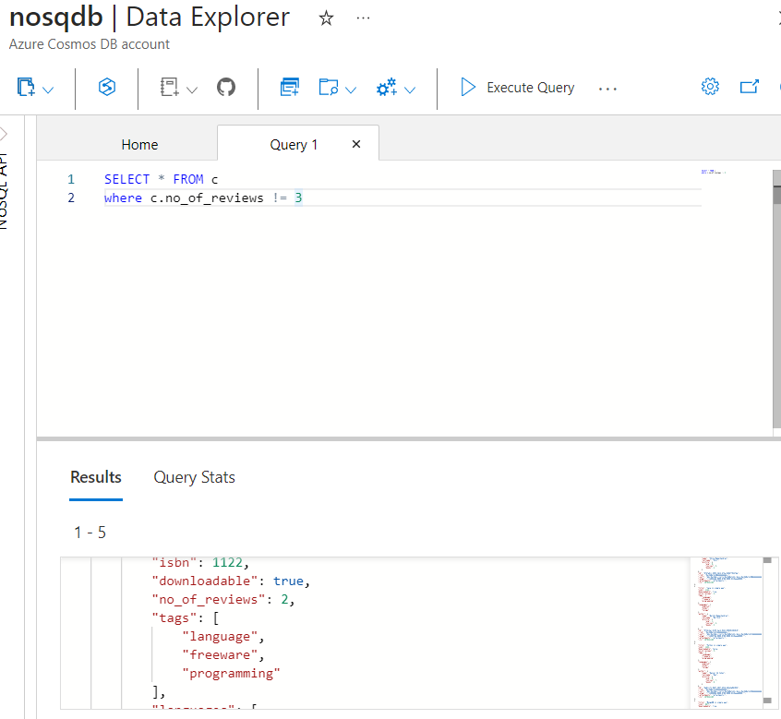

1. Select all documents where the no_of_reviews is greater than or equal to 3 and downloadable is true

🡺 select * from c where c.no_of_reviews >= 3

and c.downloadable = true

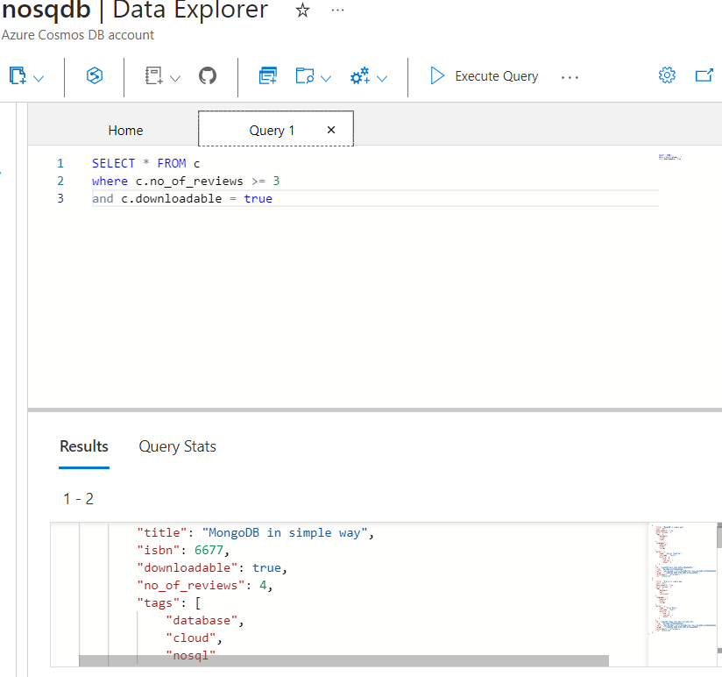

1. Select all documents from the books collection where the tags array contains either database or programming4

🡺 select * from c where array_contains(c.tags,”database”)

or array_contains(c.tags, “programming”)

